CMDh/223/2005
February 2014

Public Assessment Report

Scientific discussion

Furosemid Medreg
furosemide

SK/H/0238/001/DC

Date: February 2021

This module reflects the scientific discussion for the approval of Furosemid Medreg. The procedure was finalised at 10 January 2021. For information on changes after this date please refer to the module ‘Update’.

Introduction

Based on the review of the quality, safety and efficacy data, the Member States have granted a marketing authorisation for Furosemid Medreg, tablets, 40 mg from Medreg s.r.o., Czechia.

The product is indicated for:
- oedema of cardiac origin
- oedema of hepatic origin
- oedema of renal origin (in the case of nephrotic syndrome, treatment of the primary disease is essential)
- arterial hypertension
A comprehensive description of the indications and posology is given in the SmPC.

The marketing authorisation has been granted pursuant to Article 10(1) (generic application) of Directive 2001/83/EC.

Quality aspects

Introduction

Furosemid Medreg are white or off-white, circular tablets, 8 mm (approx.) in diameter, marked “F 40” on one side (“F” & “40” separated by break line) and plain on the other side. The tablet can be divided into equal doses.

Furosemid Medreg is available in PVC/PVDC/Al blisters packed in a carton box.

Furosemid Medreg comes in pack sizes of 10, 20, 30, 40, 50, 60, 70, 80, 90 and 100 tablets.

Drug Substance

INN: Furosemide

Molecular formula: C₁₂H₁₁ClN₂O₅S

Structure:

Appearance: White or almost white, crystalline powder. It is practically insoluble in water, soluble in acetone, sparingly soluble in ethanol (96%), practically insoluble in methylene chloride. It dissolves in dilute solutions of alkali hydroxides (European Pharmacopoeia, Ph.Eur).

Chirality: It has no chiral carbon centre.

Manufacturing: The drug substance, furosemide, is manufactured by a supplier:
Ipca laboratories Limited P.O. Sejavta India - 457 002 Ratlam, Madhya Pradesh, India.
Manufacturing process is covered by a CEP Rl-CEP 1998-020-Rev 07. The role of a Certificate of Suitability (CEP) is to certify the compliance of a material with the requirements laid down in the relevant monograph of the European Pharmacopoeia. Active pharmaceutical ingredients for which a Certificate of Suitability has been granted are suitable for use in medicinal products.

Stability: Stability studies have been performed with the drug substance. No significant changes in any parameters were observed. The proposed re-test period of 5 years if stored in double polyethylene bags (outer black), placed in a polyethylene or fiber drum was justified.

Specification: The specification was established according to the monograph on furosemide in Ph.Eur except for particle size limits, which is set by a drug substance manufacturer.

Medicinal Product

Pharmaceutical development: The aim of pharmaceutical development was to introduce generic version of the reference product Lasix immediate release tablets manufactured by Sanofi-Aventis. For formulation development, various trail batches of furosemide tablets were manufactured until a formulation was established which gave a dissolution profile comparable to the reference product and also demonstrate acceptable physical properties. A summary of experimental batches produced was provided. Batches were tested primarily for physical characteristics and dissolution profile.

The manufacturing process consists of following steps:
• Sifting of furosemide, lactose monohydrate, maize starch, and pregelatinised starch using a vibratory sifter.
• Dry mixing of material in rapid mixer granulator.
• Granulation of blend using purified water.
• Wet mass milling (if required).
• Drying at 55 ± 10°C.
• Sifting and sizing of dried granules.
• Lubrication.
• Compression of lubricated granules into tablets using a rotary compression machine.
• Packaging.

Specifications: The product specifications cover appropriate parameters for this dosage form.
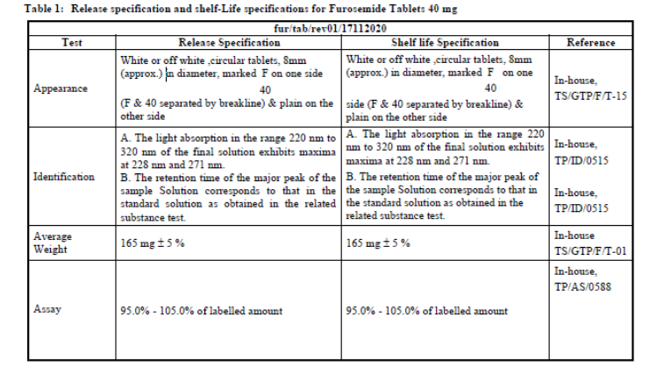
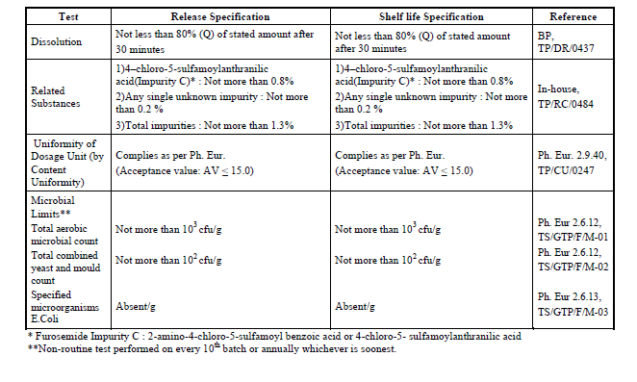

Stability: The control tests and specifications for drug product are adequately drawn up. The proposed shelf-life of 3 years was considered acceptable. Storage conditions “This medicinal product does not require any special storage conditions” were accepted.

Discussion on chemical, pharmaceutical and biological aspects

Major issue with regard to this procedure was not providing a risk evaluation of nitrosamines (NA) impurities within the registration dossier at the beginning of the procedure.
During the course of the procedure the applicant submitted missing data with regard to NA impurities and satisfactorily completed the risk evaluation of NA presence with the outcome of “no risk”. Principles outlined in the currently valid guidance (e.g. Information on nitrosamines for marketing authorisation holders (EMA/189634/2019) AND Questions and answers on “Information on nitrosamines for marketing authorisation holders” (EMA/CHMP/428592/2019 Rev. 3) have been followed.

Non-clinical aspects

Introduction

The non-clinical overview has been written by Dr Ghanashyam Rao, Medical Graduate, from ELC GROUP s.r.o., and dated 2014. Report refers 41 publications up to year 2014.

Pharmacodynamic, pharmacokinetic and toxicological properties of furosemide are well known. As furosemide is a widely used, well-known active substance, the applicant has not provided additional studies and further studies are not required. Overview based on literature review was, thus, appropriate.

Ecotoxicity/environmental risk assessment (ERA)

No ERA Assessment was submitted by the applicant and their justification for the absence of ERA studies was considered not acceptable in the initial assessment phase.

The applicant was, therefore, asked to discuss ERA in line with the current guideline EMEA/CHMP/SWP/4447/00 corr 2., and to provide consumption data (in kg/year over time, preferably for the last 4 years in SK, CZ, RO and PL) to substantiate the applicant’s claim that marketing authorisation of the proposed medicinal product is unlikely to significantly increase exposure. During the course of the procedure applicant provided justification for the absence of ERA study. Overall consumption data from CZ, SK and RO showed no significantly increasing trend of furosemide consumption.

Discussion on the non-clinical aspects

No new non-clinical studies were performed and overview of non-clinical data published in literature up to 2014 was accepted. With regard to ERA, overall consumption data from CZ, SK and RO showed no significantly increasing trend of furosemide consumption.

Clinical aspects

Introduction

To support the application, the applicant has submitted as report one bioequivalence study (study code: ARL/13/104): A randomized, balanced, open label, single dose, three-sequence, two-treatment, three-period, reference replicate, crossover, bioequivalence study of furosemide tablets, with Lasix, MAH Sanofi-Aventis, Portugal, in normal, healthy, adult, male and female, human subjects under fasting conditions.

Pharmacokinetics

Table 1 Pharmacokinetic parameters

Table 2 Bioequivalence evaluation of furosemide in ARL/13/104:

AUC_{0-t} Area under the plasma concentration curve from administration to last observed concentration at time t.
AUC_{0-∞} Area under the plasma concentration curve extrapolated to infinite time.
C_{max} Maximum plasma concentration
t_{max} Time until Cmax is reached

Conclusion on bioequivalence study:
Based on the submitted bioequivalence study Furosemid Medreg is considered bioequivalent with Lasix.

Risk Management Plan

The MAH has submitted a risk management plan, in accordance with the requirements of Directive 2001/83/EC as amended, describing the pharmacovigilance activities and interventions designed to identify, characterise, prevent or minimise risks relating to Furosemid Medreg.

- Summary table of safety concerns as approved in RMP
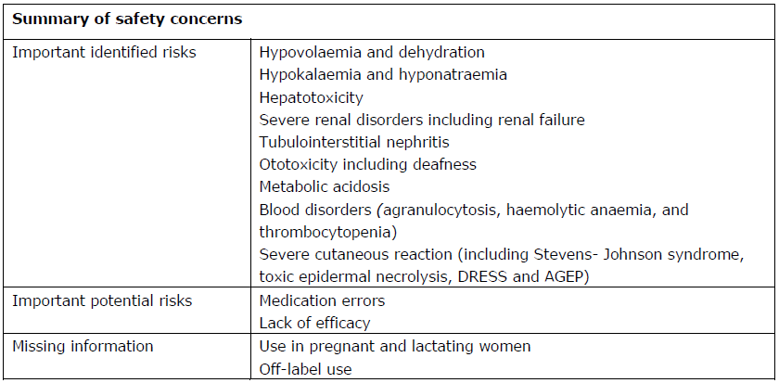

Routine pharmacovigilance was suggested and no additional pharmacovigilance activities are planned.

Discussion on the clinical aspects

For generic applications there is no need to perform repetitive test on animals and humans and therefore, to support the application, the applicant has submitted one bioequivalence study (study code: ARL/13/104) in order to establish essential similarity of Furosemid Medreg with the reference medicinal product Lasix. Based on submitted data the essential similarity between these two products was concluded.

User consultation

The package leaflet has been evaluated via a user consultation study in accordance with the requirements of Articles 59(3) and 61(1) of Directive 2001/83/EC. The language used for the purpose of user testing the PIL was English.
The results show that the package leaflet meets the criteria for readability as set out in the Guideline on the readability of the label and package leaflet of medicinal products for human use.

The distribution of participants with regard to sex, age and education degree was adequate and well according to guideline requirements. The number of rounds (one preliminary round with 2 participants, and 2 rounds with 10 participants each) was adequate.

Numbers of questions (12) did meet the criteria according to guideline. The questions covered all aspects with regard to safe and correct use of Furosemid Medreg according to instructions in PL.

All participants were able to identify correct answer in 100% cases. No corrections of PL were proposed.

All participants found PL as simple and understandable document. There were no problems with regard to readability and understanding of PL recorded.

Overall conclusion, benefit/risk assessment and recommendation

Based on the review of the quality, safety and efficacy data, the RMS SK concluded that the benefit/risk ratio of Furosemid Medreg is comparable with that of the reference medicinal product Lasix.

